Benefits Claims Decision Support System (BCDSS)

Software Design Document



**March 2017**

Version 1.15

Department of Veterans Affairs

Revision History

| Date | Version | Description | Author |
| --- | --- | --- | --- |
| 03/09/2017 | 1.15 | Updated Error code and Descriptions 9.4.5 | BCDSS Team |
| 02/09/2017 | 1.14 | Updated latest screenshots 9.4.4 and DB diagrams 6.3 and 6.3.2 | BCDSS Team |
| 01/17/2017 | 1.13 | Updated latest screenshots 9.4.2 and 9.4.3 | BCDSS Team |
| 12/20/2016 | 1.12 | Updated latest screenshots 6.3 and 6.3.2 | BCDSS Team |
| 11/17/2016 | 1.11 | Updated latest screenshots 9.4.2 | BCDSS Team |
| 10/17/2016 | 1.10 | Data model updates 6.3.2, Modeling Webservice 7.1.2 | BCDSS Team |
| 09/19/2016 | 1.9 | Data model updates 6.3.2 | BCDSS Team |
| 8/23/2016 | 1.8 | Updated latest screen shots references 9.4.1, 9.4.2 | BCDSS Team |
| 7/18/2016 | 1.7 | Updated NoSQL references  2.3 , 3.1., 3.3.3, 4.2.3, 5.3.5 | BCDSS Team |
| 6/27/2016 | 1.6 | Updated Development support user stories | BCDSS Team |
| 6/17/2016 | 1.5 | Updated screen shots | BCDSS Team |
| 4/29/2016 | 1.4 | Updated the Epics and Stories from the initial draft review | BCDSS Team |
| 4/27/2016 | 1.3 | Created Baseline Document from Draft review comments | BCDSS Team |
| 4/12/2016 | 1.2 | Requirements, Architecture, Database and Design Updates | BCDSS Team |
| 04/05/2016 | 1.1 | Architecture and Design Updates | BCDSS Team |
| 3/28/2016 | 1.0 | Template updates | BCDSS Team |
| 3/24/2016 | 0.9 | Architecture, Database and Design Updates | BCDSS Team |
| 2/07/2016 | 0.8 | Document Cleaned and Labeled | BCDSS Team |
| 2/05/2016 | 0.7 | Figures, Tables Added, RTM Inserted | BCDSS Team |
| 2/01/2016 | 0.6 | Architecture, Database, Security and Platform Design Updates | BCDSS Team |
| 1/26/2016 | 0.5 | Data Dictionary Added | BCDSS Team |
| 1/21/2016 | 0.4 | Context, Data, High-Level and Roles Updates | BCDSS Team |
| 1/15/2016 | 0.3 | Database and Logical Design Updates | BCDSS Team |
| 12/15/2015 | 0.2 | Architecture updates | BCDSS Team |
| 11/09/2015 | 0.1 | Document Creation | BCDSS Team |

Artifact Rationale

The Software Design Document (SDD) is a dual-use document that provides the conceptual design as well as the as-built design. The Benefits Claims Decision Support System (BCDSS) team will update this document as the team builds the BCDSS System to reflect the as-built product. The team based this document on the Project Management Accountability System (PMAS) ProPath Template.

Table of Contents

1. About this document 7

2. Introduction 7

2.1. Purpose of the SDD 7

2.2. Identification 7

2.3. Scope 8

2.4. User Profiles 8

2.4.1. Manage models 8

2.4.2. Ingest Claim Data 8

2.4.3. Populate Claims Data 8

2.4.4. Apply models 9

2.4.5. Review Results 9

2.4.6. Process Results 10

2.4.7. Reporting 10

2.4.8. User Management 10

3. Background 10

3.1. Overview of the System 10

3.2. Overview of the Business Process 11

3.3. Assumptions and Constraints 18

3.3.1. Design Assumptions 18

3.3.2. Design Constraints 18

3.3.3. Design Trade-offs 19

3.4. Overview of the Significant Requirements 19

4. Conceptual Design 43

4.1. Conceptual Application Design 43

4.1.1. Service-Oriented Architecture (SOA) Approach 43

4.1.2. Application Context 44

4.1.3. High-Level Application Design 45

4.2. Conceptual Data Design 46

4.2.1. BCDSS Conceptual Data Model 46

4.2.2. The BCDSS CDM Data Dictionary 47

4.2.3. Database Information 48

4.3. Conceptual Infrastructure Design 49

4.3.1. System Criticality and High Availability 49

4.3.2. Special Technology 49

5. System Architecture 49

5.1. Application Architecture 50

5.1.1. User Interface 50

5.1.2. Business Services 51

5.1.3. Technical Services 51

5.1.4. Data Transformation Services 51

5.1.5. Data Services 51

5.1.6. External Interfaces 52

5.2. Hardware Architecture 52

5.3. Software Architecture 53

5.3.1. Access Layer 53

5.3.2. Application Layer 53

5.3.3. Persistence Layer 53

5.3.4. Security Layer 54

5.3.5. Database Layer 54

5.3.6. Infrastructure Layer 54

5.4. Continuous Integration / Continuous Delivery 54

5.5. Service Oriented Architecture / ESS 54

5.6. Enterprise Architecture 54

6. Data Design 54

6.1. DBMS Files 54

6.2. Data View 55

6.3. BCDSS Data Ingest and Processing (INPUT) 55

6.3.1. BCDSS Role Based Access Control (Model Repository) 56

6.3.2. BCDSS Predictive Model Metadata 57

7. Detailed Design 58

7.1. Software Detailed Design 58

7.1.1. Application Dashboard 60

7.1.2. Server-Side Components 61

7.1.3. Manage Models 61

7.1.4. Display Target Claims 62

7.1.5. Apply Models to Target Claims 63

7.1.6. Reporting 64

7.2. Specific Requirements 64

8. Security and Privacy 65

8.1. Security 65

8.1.1. Physical Security 65

8.1.2. Network Security 65

8.1.3. Transport Security 65

8.1.4. Message Security 67

8.1.5. Application Security 67

8.1.5.1. Authentication 67

8.1.5.2. Authorization Design 67

8.2. Privacy 67

9. Human-Machine Interface 68

9.1. Interface Design Rules 68

9.2. Inputs 68

9.2.1. User Roles 68

9.3. Outputs 69

9.4. Navigation Hierarchy 69

9.4.1. Logon 69

9.4.2. Rater Dashboard 70

9.4.3. Rating Results 71

9.4.4. Reports 72

9.4.5. Error Code and Descriptions 74

10. Acronyms and Abbreviations 74

A. Additional Information 75

A.1. Identification of Technology and Standards 75

A.2. Constraining Policies, Directives and Procedures 77

A.3. Requirements Traceability Matrix 78

A.4. Packaging and Installation 78

11. Approval Signatures 79

# About this document

This Software Design Document (SDD) describes the Benefits Claims Decision Support System (BCDSS) requirements, operating environment, system architecture, database design, input formats, output formats, detailed design, processing logic, and external interfaces.

# Introduction

In 2013, Compensation Service initiated a research effort to determine the feasibility of using predictive models to automate disability claims processing and focused on requests for increased claims. This research developed predictive models to forecast disability ratings based on the type of claim, Veteran characteristics, military service, demographic data, previous claims history and ratings, and other key parameters.

To date, Compensation Service have focused research on producing predictive models for rating disability claims for the hearing and knee body systems, which represent the highest frequency of disabilities claimed. The Veterans Benefits Administration (VBA) is seeking to create a software platform to implement predictive models to rate historical disability claims.

The Department of Veterans Affairs (VA) established the BCDSS project to demonstrate the feasibility of using automation and predictive models to calculate the Combined Disability Determination (CDD) for specific conditions contained within Veteran claims for disability compensation. Such capabilities could help the VA improve the quality and consistency of its current claims adjudication decisions and potentially could provide Veterans with the ability to obtain the likely outcome of their claims for benefits at the time of filing. Both outcomes could significantly improve the veteran experience and the efficiency of VA’s claims adjudication process.

## Purpose of the SDD

The purpose of this document is to describe in sufficient detail how the proposed system will be constructed. The SDD translates requirement specifications into a document which the developers can utilize to create the actual system. It identifies the top-level system architecture, and establishes hardware, software, communication, and interface components. For the purpose of this document, “system” will be used to reference the overall BCDSS solution (User Interface (UI)/User Experience (UX), Database, Models, Modeling Engine, and Services) and “application” will be used to reference the portions of BCDSS that will interface with an end user (UI/UX).

## Identification

This SDD applies to the BCDSS as developed under the purview of the VA Center for Innovation (VACI).

## Scope

The BCDSS SDD describes the architecture, functional components, and interfaces of the BCDSS including the:

* BCDSS Database—Application will use a Relational Database Management System (RDBMS) to implement the modeling, staging, and reporting repositories of the system.
* Predictive Models for Ear and Knee—Models used when performing the predictive analytics
* Modeling Engine—The engine performing the analysis of the Claim data utilizing the models
* System Administration—UI/UX allowing administrators the ability to control access to the BCDSS application and to perform other administrative actions
* Dashboard—UI/UX allowing users to select Claims to process against selected models and view the results
* Model Management—UI/UX allowing Model Agents the ability to track CRUD (Create, Read, Update, and Delete) requests for models and to publish available models for use

This document should be read in conjunction with the BCDSS Requirements Traceability Matrix (RTM) and Requirements Document.

## User Profiles

There are eight user interaction scenarios envisioned: manage models, select claims, apply models to selected claims, review and process results, reporting, and user management. Descriptions of these scenarios as envisioned follow below.

### Manage models

The primary users in this usage model are the VA Modeling Agent teams. The BCDSS application allows modeling agent users to make controlled edits to existing models within the system. The user identifies what models should be ingested into the system. The application will execute a routine that verifies that a new model conforms to system specifications.

### Ingest Claim Data

The primary users in this usage model are the VA Modeling Agent teams. The BCDSS application allows modeling agent users to search for claims data from a pre-loaded and scrubbed data set provided by the VA. The application utilizes a mock web-service to search this data to simulate the production environment.

### Populate Claims Data

The primary users in this usage model are the VA Rater teams. The BCDSS application gets the claims data from a mock web-service repository based on the user-defined filter criteria. The BCDSS application is not going to integrate with the real-time Veterans Benefits Management System (VBMS) web-services as part of the pilot implementation. Instead, mock services will be developed by BCDSS team to test the service integration. The user selects claim(s) from the list to perform further actions. The below diagram (Figure 1) explains the mock web-service integration with BCDSS application service integration component.

Figure : Populate Claims Data



### Apply models

The primary users in this usage model are the VA Rater teams. The BCDSS application displays available models that the VA Rater will then select to process and analyze the selected claims.

### Review Results

The primary users in this usage model are the VA Rater teams. The BCDSS application will provide an interface for these users to perform required review results and perform other validations and actions on the model results.

### Process Results

The primary users in this usage model are the VA Rater teams. The BCDSS application will provide an interface to persist results into the modeling repository.

### Reporting

This model shall include both direct and indirect users. The direct users are the individuals required to generate reports. The indirect users are the consumers or target audience of the reports. The direct users will utilize the interfaces provided by the BCDSS application to generate reports and download in CSV or PDF format for indirect users.

### User Management

The primary users in this model are application administrators. The application will provide the capability for administrators to add, edit, and delete users; permissions; and other application configurations.

# Background

## Overview of the System

The BCDSS system is responsible for the ingestion of VA historical claims data and the current claim for the application of a predictive model for the automated claim adjudication and rating. The solution applies predictive models (ear and knee) stored within a managed library, to claims with related historical claimant data to produce issue-specific Combined Disability Determinations (CDDs) for supplemental claims for increases. If BCDSS proves to be operationally viable and beneficial, the system’s design will allow easy integration within the Veterans Benefits Administration (VBA)’s production claims adjudication process by enabling authorized personnel to apply the calculated ratings consistent with corresponding policy, guidance, and appropriate circumstances.

As shown in Figure 1, BCDSS will be an integrated and services based system comprised of the following:

* BCDSS Database—BCDSS will use RDBMS (Oracle) to implement the modeling, staging and reporting repositories of the system.
* Predictive Models—BCDSS Predictive models are used to forecast disability ratings based on the type of claim, veteran characteristics, military service, demographic data, previous claims history and ratings, and other key parameters.
* Modeling Engine—Modeling engine provides modeling logic for ingesting claimant data sets, determining whether the predictive models can be applied or not.
* Administrative Modules—Administrative modules provide interface to manage users, user permissions, data configurations required for the system.
* Dashboard—A dashboard is a set of graphical menus and interfaces that give the user quick access to various functions for an application. In most cases, dashboards contain information such as messages, statistics, schedules and analytics.

Figure 2 shows how the target claims input to the Dashboard. Wouldn’t it be to BCDSS DB?

Figure : Business Process Overview



## Overview of the Business Process

Section 2.4 of this document outlines the major use cases associated with the BCDSS application. Of these use cases, the ones with the most significant business process component are Apply Models and Process Results. The business process diagrams, Figure 3 through Figure 7, represent a high level overview of how the BCDSS application will integrate within these use cases, however it should be noted that the details of each business process may vary on a case by case basis. As we identify more business processes during the development process, this document will be updated.

The below process model illustrates the approach for deriving the ear and knee models and storage of these two models in the BCDSS application data repository. The BCDSS platform executes these models against claims to produce a report for user analysis of model results.

Figure : Business Process Overview



Figure : Incorporating New Models and Applying Models to Target Claims



Figure : Create New Models



Figure : Apply Models to Target Claims



Figure : User Permissions (Sub-Process)



Table : Business Process Steps

|  |  |  |  |  |  |
| --- | --- | --- | --- | --- | --- |
| **Step** | **Name** | **Type** | **Description** | **Next Step** | **Requirements** |
| **MA 1** | List All Models | User Task | User retrieves all available models | This step has 3 possible outcomes:  -Create or Updates models  -Validate models  -Review models |  |
| **MA 2** | Fetch Models | System Task | System fetches models based on the user permissions | Proceed to step MA 3 |  |
| **MA 3** | Establish/Modify Models | User Task | The user can create or update models | Proceed to step MA 4 |  |
| **MA 4** | Create New Model Request | User Task | Admin user initiates a new model request | Proceed to step MA 5 |  |
| **MA 5** | Create Model Structure | System Task | System creates model structure and populates meta data | Proceed to step MA 6 |  |
| **MA 6** | Validate Models | User Task | User validates newly created models | Proceed to step MA 7 |  |
| **MA 7** | Execute Test Data | System Task | System executes test data | Proceed to step MA 8 |  |
| **MA 8** | Compare to Thresholds | System Task | System compares the recommended ratings produced by the models to the actual historical rating. | Proceed to step MA 9 |  |
| **MA 9** | Review | User Task | User reviews the model | Proceed to step MA 10 |  |
| **MA 10** | Validation | User Task | User validates the model | This process step has two possible outcomes:   1. Approve model 2. Disapprove model   Proceed to step MA 11 |  |
| **MA 11** | Approve | User Task | User approves the model | Proceed to step MA 12 |  |
| **MA 12** | Store Model | System Task | System persists model in the model repository | End Event. |  |
| **M1** | Search/Select a target claim | User Task | The user selects a target claim | Process step M 2 |  |
| **M2** | Get Target Claim Data | System Task | System invokes Mock Web service for inbound claims data | Process Step M 3 |  |
| **M 3** | Call VBMS Shared Web-Service | System Task – External Interface Integration | System communicates to external interface | Process Step M 4 |  |
| **M 4** | Choose Models | User Task | The user selects a model | Process step M 5 |  |
| **M 5** | Filter Data | System Task | The system filters data against model, type and version | Process step M 6 |  |
| **M 6** | Process Claims | User Tasks | User selects model and claims to process claims | Process step M 7 |  |
| **M 7** | Transform Data | System Task | Transform input data and apply rating calculations | Process step M 8 |  |
| **M 8** | Matching and Testing | System Task | The system matches/compares rating data. Testing is optional step | Process step M 9 |  |
| **M 9** | Review | User Task | User reviews the final result | Process step M 10 |  |
| **M 10** | Generate Report | User Task | The user accepts all selections and generate a report | End Event. Proceed to next step |  |
| **A 1** | Manage User | User Task | Create/Update/Delete a new user | Proceed to step A 2 |  |
| **A 2** | Persist User | System Task | System stores user data | Proceed to step A 3 |  |
| **A 3** | Assign Permissions | User Task | Admin user assigns permissions to the newly created user | Proceed to step A 4 |  |
| **A 4** | Persist User Permissions | System Task | System stores user permissions | End event |  |

## Assumptions and Constraints

The details of the system design are subject to change as requirements are being gathered in parallel within an Agile development cycle.

This SDD will be regularly updated and identified with version numbers to describe the expanded system design.

Unless otherwise stated, software will be open source and compliant with One-VA's Technical Reference Model (TRM).

### Design Assumptions

The overall design and development process involves iterative development, rapid prototyping, and incorporating key stakeholder input allowing for design factoring and enhancement.

### Design Constraints

* System designers have attempted to utilize open source tools wherever possible, including the design of the user interface, testing tools, and analytics tools.
* System designers used VA tools approved for use in the One-VA TRM List of Technology or have requested a waiver for any tools not listed there.

### Design Trade-offs

It is a development goal for the system to provide a feature-rich and responsive Dashboard UI. The Predictive Models provide the analysis to drive the UI. The development team assumes that the number of users will be relatively low and the responsiveness of the Model processing is essential. Thus, the BCDSS Application is architected to scale by ensuring that performance does not degrade as the number of users increases and as additional data becomes available. This architectural focus can be demonstrated in the following design trade-offs:

* Maximize the responsiveness of the UI by utilizing client-side controllers, and only making network calls to retrieve data. This is achieved through the use of a Single Page Application.
* Favor an asynchronous Application Programming Interface (API) to maximize performance. If an API call is synchronous, it means that code execution will block (or wait) for the API call to return before continuing causing possible performance issues. Asynchronous calls do not block (or wait) for the API call to return from the server allowing execution to continue in the application.
* The development team will use an Oracle database for modeling, staging, and reporting repositories as part of pilot development scope.
* Favor the usage of micro-services, rather than traditional web-server clusters, to maximize discrete scalability options and ensure that services remain loosely coupled.

## Overview of the Significant Requirements

The table below includes an overview of the major user requirements associated with the proposed solution. A full listing of the project’s Product Backlog is maintained in JIRA at [https://bcdssteam.atlassian.net/issues/?jql=](https://bcdssteam.atlassian.net/issues/?jql=%20)

In addition, a more detailed snapshot of the project’s major functional requirements will be included in the project’s RTM. The VABCDS tags in the table below, for example, “VABCDS-173,” derive from the tracking system in Jira.

Table : Epics and User Stories

|  |  |  |  |
| --- | --- | --- | --- |
| **EPIC ID** | **User Story ID** | **Summary of Technical Requirement** | **Description of Technical Requirement** |
| VABCDS-149 |  | BCDS - Benefits Claims Decision Support System Application | As a Customer, I want to build a System with the capability to provide predictive models for providing a recommended rating for the contentions on the Veteran's claim so I can improve the delivery of benefits to the nation’s Veterans.  Assumptions: The testing area will consist of a shared environment that mimics the VA production environment where the proof of concept may be tested.  Acceptance Criteria: The new System (proof of concept) is built to generate recommend ratings for contentions of the claims. The new System will be able to handle end to end from retrieving the adjudicated claims to providing recommended ratings for the contentions of the claims. |
| VABCDS-173 | VABCDS-188 | BCDS - Login authentication | As a user, I want to login into the BCDS application so I can utilize predictive models to rate VA disability claims.  Assumptions: The system has the Login page built-in and has the fields to enter the respective User ID and Password.  Acceptance Criteria: Authorized user is able to enter User ID and Password and successfully login into the BCDS application Authorized user is able to successfully access the respective Dashboard to perform user's task. |
| VABCDS-281 | BCDS - Wireframes: Login authentication, Rater Dashboard and Search | Ongoing Storyboard preparation meeting with the Product Owner.    Objectives  * Agree on the schedule for this meeting with PO and SME  * Wireframe draft preparation  * Internal Wireframe discussion |
| VABCDS-283 | BCDS - Data base objects for Login authentication | Decide the database objects needed for Login authentication |
| VABCDS-543 | BCDS - Application Session Termination | As a BCDS user, I want the BCDS system to terminating a user session after a period of 60 minutes of inactivity with a two-minute warning before termination. So that the BCDS system adheres to the Veteran Affair's security policy.    Note:   If the session does time out, the user would be redirected to the Login screen to log into BCDS again. Note that, the next time user logs into BCDS he/she is NOT redirected to the location where the session ended. |
| VABCDS-174 | VABCDS-189 | BCDS - Authorization Define Roles - Administrator | As BCDS System, I need to define administrator user role to the System, so that I can provide control, capability, and limitation to the BCDS application    Dependency: decision on user accounts, logins, and roles relationship structure.    Acceptance criteria: Administrator Role definitions and capabilities. |
| VABCDS-190 | BCDS - Authorization Define Roles - Rater | As BCDS System, I need to define rater user role to the System, so that I can provide control, capability, and limitation to the BCDS application    Dependency: decision on user accounts, logins, and roles relationship structure.    Acceptance criteria: Rater Role definitions and capabilities. |
| VABCDS-191 | BCDS - Authorization Define Roles - Modeling Agent | As BCDS System, I need to define modeling agent user role to the System, so that I can provide control, capability, and limitation to the BCDS application    Dependency: decision on user accounts, logins, and roles relationship structure.    Acceptance criteria: Modeling Agent Role definitions and capabilities. |
| VABCDS-368 | BCDS - Create Administrator User Role | As a BCDS Developer, I need to create administrator user role in the System, so that the user login with Administrator access have the Administrator Role's control, capability, and limitation to the BCDS application    Dependency:     Acceptance criteria: |
| VABCDS-369 | BCDS - Create Modeling Agent User Role | As a BCDS Developer, I need to create modeling agent user role in the System, so that the user login with Modeling Agent access have the Modeling Agent Role's control, capability, and limitation to the BCDS application    Dependency:     Acceptance criteria: |
| VABCDS-370 | BCDS - Create Rater User Role | As a BCDS Developer, I need to create rater user role in the System, so that the user login with Rater access have the Rater Role's control, capability, and limitation to the BCDS application    Dependency:     Acceptance criteria: |
| VABCDS-562 | BCDS - Implementation of Role based resource access |  |
| VABCDS-175 | VABCDS-400 | BCDS - Admin Dashboard requirements | As an Admin, I need to have a dashboard so I can add users (Rater, Modelling Agent, and Administrator) to the BCDS Application, to run Models (Rater), update models (Modelling Agent), and Manage users (Administrators).    Following would be covered under this story  Requirement gathering with business and SMEs  Internal review with the developers  Mockups  and concurrence by business |
| VABCDS-408 | BCDS - Administrator Dashboard | As an Administrator of the BCDS application, I want to be able to Create new users (Rater, Modelling Agent, and Administrator), Update user roles, Activate/Deactivate users, So that I can Manage the users of the BCDS application.    Assumption:   The admin is logged into the application    Acceptance Criteria:  Admin is able to Create new users  Admin is able to Activate/Deactivate users  Admin is able to reset password |
| VABCDS-442 | BCDS - Administrator: Add User functionality along with Email | As an Administrator, I need to be able to add and create user in the user management page of the Administrator's Dashboard.    Assumption: all new users need to create by the administrator.    Acceptance Criteria: The admin is able to add user info. |
| VABCDS-176 | VABCDS-192 | BCDS - Dashboard - Modeling Agent | NOTE: This story covers portion of the below mentioned story of creating a dashboard same as Rater. Rest of the portion of the story is covered under Stories 375, 376, and 377.    As a Modeling Agent, I need the ability to have a dashboard so that I can create, update, delete and review predictive models and review the progress of the processed claims    Assumption: The Modeling Agent is successfully logged into the BCDS system    Acceptance Criteria: Modeling Agent is able to view and access the necessary fields required to review the progress of the processed claims |
| VABCDS-193 | BCDS - Dashboard - Rater | As a Rater, I need the ability to have a dashboard, So that I can access all claim information, choose models, review and generate reports, and perform ratings against models.    Assumption: The Rater is successfully logged into the BCDS system    Acceptance Criteria:   Rater is able to successfully access the claims and it's contentions |
| VABCDS-176 | VABCDS-194 | BCDS - Claim Retrieval | As a Rater, I want to retrieve Veteran's claims so that I can run predictive model on it based on the contention    Assumptions:   The 3rd party system is up and running to retrieve claims (For this initial proof of concept - it will be retrieved from internal database)  The retrieved claims are adjudicated    Acceptance Criteria:   The system should be able to successfully retrieve the adjudicated claims and it's contentions  Rater is able to process the selected and obtain predictive rating |
| VABCDS-254 | BCDS - Define UI templates and development standards | As a dev lead, I want to develop user interface templates and development standards to meet client’s requirements. So that development team can develop consistent user interface and streamlined development process for BCDS application. |
| VABCDS-291 | BCDS - Administrator's Dashboard | Mockup/wireframe of the Administrator's dashboard |
| VABCDS-307 | BCDS - Wireframe: Modeling Agent Dashboard | Create wireframes for Model Agent dashboard |
| VABCDS-372 | BCDS - Rater Dashboard: Search Claims (Advanced Search) | As a Rater, I need to be able to search a specific claim or set of claims from the sample data provided, so that I can run the predictive model for that specific claim(s).    Assumption: The user is aware of the claim(s) available in the sample claims provided.    Acceptance Criteria: The search must return the claims based on the entered search criteria. |
| VABCDS-373 | BCDS - Dashboard: Filter Claims | As a Rater, I need to be able to filter a specific claim or set of claims from the sample claims retrieved on the dashboard, So that I can run the predictive model for those specific claim(s).    Assumption: Sample claims are successfully retrieved on the dashboard    Acceptance Criteria: The user is able to filter the claims based on the fields(columns) in the attached mockup |
| VABCDS-374 | BCDS - Dashboard: Sort Claims | As a Rater, I need to sort the claims by the fields (columns) from the sample data retrieved on the grid, So that I can choose the claims and run the predictive model for those    Assumption: The claims are successfully retrieved in the grid    Acceptance Criteria: The system shall have the capability to sort the claims based on the selected fields |
| VABCDS-395 | BCDS - Establish DB connection and query for Rater's Dashboard | As a developer, I want to Establish DB connection and query for Rater's Dashboard, so that I can retrieve the claims from database. |
| VABCDS-396 | BCDS - Modelling Agent Dashboard: Create claims page | As a developer, I want to create claims page, so that I can retrieve claims their |
| VABCDS-397 | BCDS - Modeling Agent's dashboard: create data object for claims page | As a developer, I want to data objects for claims page so that target claim data from BCDS database |
| VABCDS-398 | BCDS - Modelling agent: Dashboard design | As a developer, I want to design the dashboard, so that I can capture all the component required for the dashboard. |
| VABCDS-399 | BCDS - Establish DB query for Modelling Agent's Dashboard's Claims page |  |
| VABCDS-443 | BCDS - Administrator Dashboard : Edit User | As an Administrator, I need to be able to edit user information in the user management page of the Administrator's Dashboard to update or correct user info.    Assumption: user has been created and is in the system.    Acceptance Criteria: The admin is able to edit user info. |
| VABCDS-444 | BCDS - Modeling Agent Dashboard: Models Page | As a Modeling Agent in the BCDS application, I need a dashboard page to display all models in the BCDS application so I can manage the models of the BCDS application.    Assumption: The Modeling Agent is logged into the application.    Acceptance Criteria:  # Modeling Agent is able to view all models and versions.  # Modeling Agent is able to authorize/forbid model version for raters.  # Modeling Agent is able to edit model to create new versions. |
| VABCDS-447 | BCDS - Administrator: Enable and Disable User Role for Users | As an Administrator, I need to be able to enable user with only one user role or disable all possible roles in the user management page of the Administrator's Dashboard.    Assumption: User has been created and is in the system.    Acceptance Criteria: The Admin is able to enable and disable user role. |
| VABCDS-461 | BCDS - Populate DB data in Rater's Dashboard | As a developer, I want to use the rest service to get the claims data and display in the Rater's dashboard. |
| VABCDS-462 | BCDS - Populate DB data in Modeling Agent -Dashboard | As a developer, I want to use the rest service to get the modeling agent data and display in the Modeling Agent's dashboard. |
| VABCDS-466 | BCDS - Rater's Dashboard - refactor data entity | As a developer, I want to refactor the data entity for the Rater's dashboard data so it can be ready for the repository. |
| VABCDS-467 | BCDS - Rater's Dashboard - create entity access service via spring jpa | As a developer, I want to create a repository for the data entity for the claims data so it can be ready for data service. |
| VABCDS-468 | BCDS - Rater's Dashboard - create data service | As a developer, I want to create the data service for the repository for the claims data entity. |
| VABCDS-469 | BCDS - Rater's Dashboard - create rest service | As a developer, I want to create a rest service to be able to get the data from the repository and pass to the Rater's dashboard |
| VABCDS-470 | BCDS - Modeling Agent's Dashboard - refactor data entity | As a developer, I want to refactor the data entity for the modeling agent's dashboard data so it can be ready for the repository. |
| VABCDS-471 | BCDS - Modeling Agent's Dashboard - create repository | As a developer, I want to create a repository for the data entity for the claims data so it can be ready for data service. |
| VABCDS-472 | BCDS - Modeling Agent's Dashboard - create data service | As a developer, I want to create the data service for the repository for the claims data entity. |
| VABCDS-473 | BCDS - Modeling Agent's Dashboard - create rest service | As a developer, I want to create a rest service to be able to get the data from the repository and pass to the Modeling Agent's dashboard page. |
| VABCDS-623 | BCDS: Bulk Processing of Claims - Future requirement | As a Modeling Agent, I want to be able to process a large number of claims at once, so that the supplemental claims can be processed faster.    Acceptance criteria:   # The Modeling Agent is able to process large number of claims at once.  # The Modeling Agent is able to filter a defined set of claims by Date, RO, and Contention to be able to process the same.    Note:   * The Accept/Reject feature would not be required for processing bulk claims.  * Only Modeling Agent shall have this capability to process bulk claims.    Discussion emails and wireframes attached (reviewed by business). |
| VABCDS-177 | VABCDS-195 | BCDS - Disability Predictive Model Selection | *Note: There may not be the need for the user to manually select the Model as the Model IDs are used to map the contention on the Dashboard itself and could directly process the respective model to get the results* - Please check with Vasu/CJ to confirm the same when picked for development.    As a Rater, I need the system to show the respective disability predictive model based on the contention so that I can predict the compensation for the disability.    Assumptions: The disability predictive models are available and ready to use.    Acceptance Criteria: Based on the selected Knee or Ear disability contentions, the user should have the option to select the respective (Knee and Ear) predictive model to process. |
| VABCDS-196 | BCDS - Alerts for unavailability of Disability Predictive Model | As a Rater, I need the system to show an alert in case the predictive model is not available for the selected contention, so that it can be handled accordingly.    Assumptions: The Predictive Model is unavailable.    Acceptance Criteria: Displayed alerts should have details to contact the respective representative to get the issue resolved (for this concept project it's going to be the contact details of the person handling the predictive models). |
| VABCDS-202 | BCDS - Identify Contention in Claim that can be rated | As a Rater, I need the system to have the capability to identify which contention on each claim can be rated using the Predictive Model, so that I can rate those contentions using the respective predictive model.    Assumption:  # Claims are successfully received in the BCDS application.  # Contentions exists in the retrieved claims.  # BCDS Model is available for Disease of the Ear and Knee disabilities in the Repository.  # List of keywords will be gathered and provided by the Functional Analyst to identify the Ear and Knee BCDS Model Repository (this needs to be discussed further to see if this is really needed for the initial two Models).    Acceptance Criteria: System should be able to determine contentions on each claim that can be rated. If there are contentions for Ear and Knee (i.e., key words for Knee and Ear for example), then the system should be able to determine and shortlist those contentions only to process. |
| VABCDS-377 | BCDS - Model Agent: Select Model to Process | As a Modeling Agent, I want the option to select the model to process based on the contentions. When selecting the model, I want to have an option to select any/other version of the model on file (versions that are not yet authorized) so that I can run the updated model/other model for the body system and be able to view the accuracy of the results. |
| VABCDS-178 | VABCDS-197 | BCDS - Process Predictive Model by Contention | As a Rater, I need to be able to process each contention of the claim separately so that I can predict and evaluate each contention's rating output.    Assumption: Predictive model is available.    Acceptance Criteria: Predictive models are available and able to provide the output based on the contentions. |
| VABCDS-179 | VABCDS-198 | BCDS - View Clinical Data associated to the claim (Not in scope) | As a Modeler,I need to view the Evidences (clinical data) associated with the claimSo that I can verify the accuracy    Assumption: Clinical data, evidences are associated to the claims    Acceptance criteria: The Modeler should be able to view the associated clinical data, evidences to the claim |
| VABCDS-199 | BCDS - View Predicted Results of the Processed Contentions | As a Rater, I need to view the output of the Predictive Model, so that I can compare it with the actual Rating output.    Assumption: Predictive models are available and able to successfully process the contention.    Acceptance Criteria: There is a compensation assigned to the processed contention. |
| VABCDS-200 | BCDS - Store Predictive Model's Result | As a Rater, I need to be able to store the Predictive models results in the BCDS Model repository so that I can use it in future.    Assumption: Predictive models are available and able to successfully process the contention.    Acceptance criteria: The compensation (output) generated by the predictive model is successfully stored in the BCDS Model repository. |
| VABCDS-602 | BCDS - Implement Accept/Reject workflow | As a Rater, I want to be able to Agree/Disagree the Model generated results, so that I can provide my inputs on the model results. |
| VABCDS-180 | VABCDS-201 | BCDS - Receive Feeds from Supplemental Claims for Increase | As a Rater, I need the system to have the capability to receive feeds from new supplemental claims for "disability of the Ear" and "Knee" (received from the Veterans) requesting increase in compensation for the previously rated claim so the supplemental claim for increase for disabilities of the Ear and Knee can be predicted using the predictive model.  Assumption:  1.The supplemental claim for increase has unique claim ID.  2. The external system from which BCDS application will be retrieving is available all time.  3. Support from the external system exists as needed to integrate with BCDS to receive the Supplemental claims.   Acceptance criteria: The System should be able to receive supplemental claims for increase for "disabilities of the Ear" and "Knee" disabilities. The system shall display an error message when the external system where the supplemental claims for increase are retrieved from is unavailable or fails to provide the feeds. |
|
| VABCDS-181 | VABCDS-202 | BCDS - Identify Contention in Claim that can be rated | As a Rater, I need the system to have the capability to identify which all contention on each claim can be rated using the Predictive Model, so I can rate those contentions using the respective predictive model.   Assumption:  1. Claims are successfully received in the BCDS application.  2. Contentions exists in the retrieved claims.  3. BCDS Model is available for Disease of the Ear and Knee disabilities in the Repository. 4. List of keywords will be gathered and provided by the Functional Analyst to identify the Ear and Knee BCDS Model Repository (this need to be discussed further to see if this is really needed for the initial two Models).   Acceptance Criteria: System should be able to determine contentions on each claim that can be rated. If there are contentions for Ear and Knee (i.e., keywords for Knee and Ear for example) then the system should be able to determine and shortlist those contentions only to process. |
|
| VABCDS-182 | VABCDS-203 | BCDS - Retrieve and Display Veteran's Claim history | As a Rater, I need the BCDS System to have the capability to retrieve and display data from the Veteran's claim history, claim text, and Veteran Demographic information so it's available in the BCDS system and could be viewed when needed.  Assumption: The historical data is available for the respective claim.  Acceptance Criteria: They System should be able to retrieve Veteran's claim history, Claim text and Veteran Demographic information. |
|
|
| VABCDS-183 | VABCDS-204 | BCDS - Save and Orchestrate Models | As a Rater, I need the system to orchestrate the models and corresponding data and find appropriate pattern match from DDM so I can obtain predictive rating.  Acceptance Criteria: The system should be able to orchestrate the models and corresponding data in the Predictive model Repository.  The Models should be able to process the contention of the claim to provide recommended ratings for the contentions of the claim.  Note: Only "Disease of the Ear" and "Knee" Models are in scope for Pilot project. |
|
| VABCDS-185 | VABCDS-206 | BCDS - Separate Model Logic and Platform Logic | As a Modeling Agent, I need the system to have the capability to keep the "Model Logic" separate from "Platform code" so "Model Logic" and "Platform Code" can be edited independently.  Assumption:  The Modeling Agent is Logged into the BCDS. The Modeling Agent has authorization to edit Model Logic and/or Platform Logic.  Acceptance Criteria: The Model Logic code (Predictive Model's code) and the Platform code are kept separate. |
|
| VABCDS-207 | BCDS - Provide Edit capabilities to Model Logic. | *Note: Based on the discussion with Elizabeth on 4/27/2016 - Just keep this Epic as an option in case something simple is possible.*   As a Modeling Agent, I need the system to have the capability to allow to author, modify and manage the Model Logics and Platform independently so I can make changes to Model logic and Platform Logic without depending on the BCDS system developers.  Assumption:  The Modeling Agent is logged into the system. The modeling agent is authorized to make changes to the Predictive Models. The modeling agent bares complete responsibility in doing the changes to the Predictive Models.  Acceptance Criteria:  The Modeling Agent should be able to make changes to the Model Logic without the BCDS System developers help. |
| VABCDS-186 | VABCDS-208 | BCDS -Produce Analysis Reports for each Rated Contention | As a Rater, I need the system to have the capability to produce reports for viewing for each rated contention with the details of analysis how the BCDS system recommended rating was achieved and all the relevant supporting information so I can understand and validate the model rating produced by BCDS.  Assumption:  1. The Rater is successfully logged into the system. 2. The system has successfully processed contentions of the claims.  Acceptance Criteria:  1. The system shall generate report for each rated contention with the analysis details of how the rating was determined by the models for each contention. 2. The generated report should be made available to the Rater. 3. The report should be temporarily saved in the system so it could be uploaded to the Veteran's eFolder.  Note: Report requirements (fields) will be discussed with the business. |
|
| VABCDS-187 | VABCDS-209 | BCDS - Generate and Display Analysis Reports for each Rated Contention | As a Rater, I need the system to generate the report and display the report for each rated contention in a format that’s compatible to be accepted by eFolder so I can review and analyze the output.  Assumption: The Ear/Knee contentions are successfully evaluated.  Acceptance Criteria:  The Rater is able to view the reports for each and every contention rated. The Report format should be compatible to be uploaded in eFolder.  Note: Report requirements and mockups will be gathered and updated later. |
| VABCDS-210 | BCDS - Store Analysis Reports for each Rated Contention | As a Rater, I need the ability to save the generated analysis report to the local system so I may store the report to eFolder where needed.  Assumption: The report is successfully generated for each contention determined.  Acceptance Criteria: The analysis report on how the rating is derived for each contention is stored in the local system to be stored in Veteran's eFolder when needed. |
| VABCDS-213 | VABCDS-211 | BCDS - Compare Predictive Ratings with Actual Historical Ratings | As a BCDS Team member, I need to have a mechanism built into the application to compare the BCDS generated predictive rating with that of the actual ratings.   Assumptions: The historical actual ratings will be provided to compare the BCDS output with it.  Acceptance Criteria: The system has the capability to compare the results of the Actual Rating and BCDS Recommended Rating contentions of the claim. |

# Conceptual Design

## Conceptual Application Design

The BCDSS application applies the principle of a Service-Oriented Architecture (SOA) for an interface-based design approach. This approach provides a logical partition of the separation of concerns of the system allowing back-end implementations to change without affecting the entire system. The BCDSS application architecture can be represented in the following layers illustrated by Figure 8:

Figure : Application Design



.

### Service-Oriented Architecture (SOA) Approach

The BCDSS system will implement an SOA. This approach provides a flexible and scalable architecture that allows BCDSS to support the unique needs of the technical implementation. SOA enables the solution to focus on implementing business solutions rather than application or technical solutions.

SOA is a process-centric architecture. It provides the capability to assemble discrete services in such a way to deliver distinctive business services and capabilities. The functionality is distributed across services, rather than building business logic directly into an application.

Integration of functionality occurs at the process-level, not the application-level. This allows flexibility in design and the agility to adjust as business needs change and organizations look to optimize business processes.

In building a SOA, there are two primary considerations:

1. How to integrate both internal and external services, applications and systems
2. How to build business processes to deliver business capabilities

### Application Context

While traditional ratings must remain in place, this proposed approach introduces other tool for the RVSRs to utilize. The BCDSS solution is a cutting-edge approach to add efficiencies to the ratings process already in place at the VA. The BCDSS application context components are illustrated in the Figure 9 and components description explained in Table 3.

Figure : System Architecture



Table : Application Context Description

| Name | Description | Interface Name | Interface System |
| --- | --- | --- | --- |
| Application Dashboard | Application dashboard provides a set of graphical menus and interfaces that give the user quick access to various functions for an application. | HTTP(s) and SQL query | VA Users |
| Predictive Models | This component provides the established predictive models to determine ratings for issues contained within relevant claimant datasets. | HTTP(s) and SQL query | Modeling Engine |
| Modeling Engine | This component provides the platform and modeling logic for ingesting claimant datasets, determining whether the predictive models can be applied, applying the predictive models, and outputting either auto-rated issues and the related report for the claimant dataset, or the ineligible issues for the claimant dataset. | SOAP and SQL query | BCDSS Database, Mock Web-Service |
| Reports | This component provides information to the users on the data ingest and auto-adjudication system output using predefined format. Users will be able to download reports into CSV and PDF formats to their local systems. | SQL Query | BCDSS Database |
| BCDSS Database | This component stores statistically relevant enterprise data supporting current and future predictive models. These data will be used to formulate, validate, and refine current and future predictive models. This component also maintains users and role-based security information. | SQL Query | Oracle Database |
| External VA Interface | This component allows authorized users to get the target claims data from VBMS system. | SOAP | VBMS System |

### High-Level Application Design

The BCDSS application uses Angular.js as client-side technology and will handle all requests flowing from client-side pages to server side. It uses Node.js as a server-side technology that will handle processes such as loading an application with all the required packages, and make a server for handling any HTTP request for web application. Express.js will be used for Rest-based web-services.

All server-side business components are developed using ReST API, Java/Spring technology and service integration components are developed using Java, ReST, and SOAP.

Java/spring framework components are used to manage the data flow between the layers. We will utilize Java for simple objects that provide utilities to the application, as well as to implement business logic such as application rules, calculations, validations etc., and provide other supporting services such as interfaces between BCDSS and Mock Webservices.

Figure 10 illustrates the high-level design approach of the BCDSS application that processes claims against models to produce a report for user analysis of model results.

Figure : High-Level Application Design



## Conceptual Data Design

### BCDSS Conceptual Data Model

Figure 11 is the BCDSS that defines the high-level business entities that support the BCDSS business process for predicting benefit rating. It captures the course-level information for what the system needs to rate a claim and the results of the predictive model for reporting. It also addresses the high-level information for how the application will manage security for users.

Figure : BCDSS Conceptual Data Model

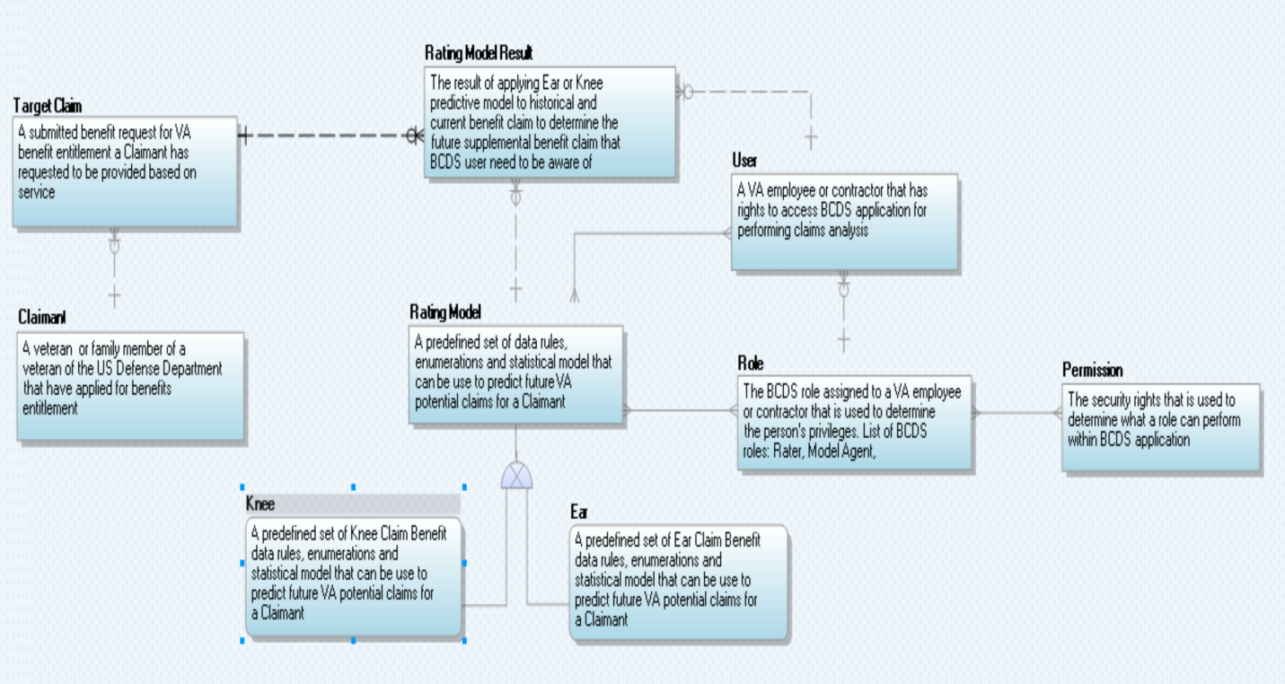

### The BCDSS CDM Data Dictionary

Table 4 is the data dictionary that defines each of the high-level business entities.

Table : BCDSS Data Dictionary

| Data Object | Type | Description |
| --- | --- | --- |
| User | Entity | A VA employee or contractor who has rights to access BCDSS application for performing claims analysis. |
| Ear | Entity | A predefined set of Ear Claim Benefit data rules, enumerations, and statistical models that can be used to predict future VA potential claims for a Claimant. |
| Knee | Entity | A predefined set of Knee Claim Benefit data rules, enumerations, and statistical models that can be used to predict future VA potential claims for a Claimant. |
| Rating Model | Entity | A predefined set of data rules, enumerations, and statistical models that can be used to predict future VA potential claims for a Claimant. |
| Target Claim | Entity | A submitted benefit request for VA benefit entitlement a Claimant has requested based on service to be rated using predictive models. |
| Claimant | Entity | A veteran or family member of a veteran of the US Defense Department who has applied for benefits entitlement. |
| Role | Entity | The BCDSS role assigned to a VA employee or contractor that is used to determine the person's privileges. List of BCDSS roles: Rater, Model Agent, Administrator, and Modeling Analyst. |
| Rating Model Result | Entity | A predefined set of data rules, enumerations, and statistical models that can be used to predict future VA potential claims for a Claimant. |
| Permission | Entity | The security rights that is used to determine what a role can perform within BCDSS application. |

### Database Information

Table 5 lists the logical data repositories that BCDS will use for acquiring, processing and providing reporting functionality to users.

Table : Database Inventory

| Database Name | Description | Type | Steward |
| --- | --- | --- | --- |
| Model Repository | A data repository responsible for persisting Ear & Knee predictive models and the associated data for operation of the BCDSS application. | Relational Database Management System (RDBMS) | TBD |
| Reporting Repository | A data repository responsible for persisting the results of the predictive model and ratings determination for reporting and analysis purpose. | Relational Database Management System (RDBMS) | TBD |
| Staging Repository (INPUT) | A data repository responsible for staging of data and preparation of data and predictive models before processing. | Relational Database Management System (RDBMS) | TBD |

## Conceptual Infrastructure Design

The architecture of this system supports cloud computing and the principles of One-VA Enterprise Architecture (One-VA EA). The BCDSS is intended to be implemented on a virtual or single-cloud resource.

### System Criticality and High Availability

The BCDSS is not a high availability system. System redundancy is not a requirement within this innovation program at this time. The availability of this system is expected to be 99.9% uptime except when the underlying infrastructures are not available due to maintenance.

### Special Technology

As the BCDSS Innovation requires addition of and is granted approval or waivers for any special technologies listed below, Table 6 will be updated.

Table : Special Technology Requirements

| Special Technology | Description | Location | TRM Status |
| --- | --- | --- | --- |
|  |  |  |  |

# System Architecture

The system developed under the BCDSS project will be designed to run in a cloud-based environment consistent with the principles of One-VA EA. The following diagram (also shown in Section 4.1.2) provides an overview of the System Architecture.

Figure : System Architecture



## Application Architecture

The application architecture describes how various components of the BCDSS Solution are integrated with each other to build an integrated application. The BCDSS is multi-tiered, modular, and rule based application. The application is based on the principles of SOA, and employing open standards for interfaces making it configurable to meet VBA requirements.

Figure : Application Architecture



In Figure 13 above, service components are built for interoperability. Services adhere to the Web Services Interoperability (WS-I) standard and are based on the Service Contract Specification. Services within this layer are classified into the following categories.

### User Interface

The User Interface Layer provides graphical user interfaces to application users to access services through various access channels.

The BCDSS is a web-based application that will utilize an approved and modern framework of technologies. At the lowest level, HTML 5 provides the basic markup language, facilitating cross-platform rendering. Cascade Styling Sheets (CSS) modularize and abstract the styling presentation away from the content represented within HTML 5. Java Script (JS) provides dynamic interface capabilities and service interaction. Development interaction with the lower levels of the presentation layer are managed using two primary frameworks. The first one is Twitter Bootstrap, which provides common UI components comprised from pre-defined HTML and CSS compositions. The second one is AngularJS, a popular JS based framework utilizing a declarative approach to providing development of a user interface.

### Business Services

Business Services encapsulate the application and business logic that supports BCDSS business functions. Services within this layer are invoked in various methods. Trusted application components and services in other architecture layers may invoke services directly via open Java EE-compliant Application Programming Interfaces (APIs). This method of invocation is often preferred for performance reasons when both the consumer and provider are known and within trusted zones, are both contained within the BCDSS system boundary, or exist within the same Java container.

Rules Services within solution provide the encapsulation and isolation of business rules logic for implementing policy and complex rules.

Report service provides BCDSS Application Reports from the BCDSS Model repository using SQL queries.

### Technical Services

Technical services include common architecture services (such as batch management, auditing, and exception handling) and those services used by applications to access the core set of functionality provided by other software. This software is plugged into the BCDSS framework, including business rules management and reporting functionalities.

### Data Transformation Services

Data Transformation services are used to process the data from one format, such as XML or SOAP, into another. The data transformation service transforms target claims data from Mock web-services to the BCDSS application components.

### Data Services

Data Services provide the application access to shared data. The Data Services components are written in Java and use open standards and specifications. The Data Services are coded to the Java Persistence API (JPA), a data-management framework, and employ object to relational mapping techniques to access data within the underlying Database Management System (DBMS).

Data services will be developed to expose the results of predictive models processing, as well as, the accuracy of the models. Data services regarding:

* Properties and metadata of the predictive models within the platform repository will use Oracle as the underlying data store for serving this type of information to external systems.
* Results of processing target claims against predictive models will be exposed via data services.

### External Interfaces

The solution’s first implementation is for a prototype within the VA’s FTL-GC Sandbox (Amazon-based) cloud environment. The BCDSS application will not integrate with the real-time VBMS web-services as part of the pilot implementation. Instead, mock web-services will be developed by the BCDSS team to test the service integration.

## Hardware Architecture

The BCDSS will initially be deployed within the VA Cloud Integration environment. Table 7 explains various hardware components required for the Dev and Test environments.

Table : BCDSS Hardware Configuration

| Hardware Item # | Hardware Item | Environment | Description | Operating System | Count |
| --- | --- | --- | --- | --- | --- |
| 1 | Web servers | Dev | Apache HTTP server 8GB RAM and 100 GB Storage | Windows | 1 |
| 2 | Application Servers | Dev | Tomcat and Reports server 8 GB RAM and 100GB Storage | Windows | 1 |
| 3 | Database Server | Dev | Oracle 11g Database 8 GB RAM and 200 GB Storage | Windows | 1 |
| 4 | Web servers | Test | Apache HTTP server 8GB RAM and 100 GB Storage | Windows | 1 |
| 5 | Application Servers | Test | Tomcat and Reports server 16 GB RAM and 100GB Storage | Windows | 1 |
| 6 | Database Server | Test | Oracle 11g Database 8 GB RAM and 200GB Storage | Windows | 1 |

## Software Architecture

The BCDSS enterprise web application is a lightweight, browser-based application that does not require installation of additional software on the user's desktop. Figure 14 below depicts BCDSS software architecture approach provides a clean separation between the presentation and application layers. The web application is browser-independent and is designed to operate on Internet Explorer 11 with only minimal hardware-related requirements.

Figure : Software Architecture



### Access Layer

The Access layer provides interfaces to application users to access services through various channels. Access to the applications will be provided through Web Application and External Interface integration.

### Application Layer

The Application layer consists of system-specific business services, which encapsulate the application and business logic that supports BCDSS business functions.

### Persistence Layer

The Persistence layer or Data services layer provides the application access to shared data. The BCDSS data services components will be developed using JPA, a data-management framework, and employ object to relational mapping techniques to access data within underlying RDBMS.

### Security Layer

Security services represent a specialized form of architecture services that provide applications with a vendor-agnostic approach to performing authentication and access management actions. The identity and access management integration is out of scope for the current BCDSS pilot application. The application provides only role-based access control that determines if the user can access the requested resource. The security services will be developed using Spring security and implemented using custom Java components.

### Database Layer

The database layer provides secure, integrated, and consistent access to system data using an Oracle database. Updates to data in any particular data store can only be made by business logic in the BCDSS application.

### Infrastructure Layer

The infrastructure layer describes the overall capabilities provided by the infrastructure and the products supporting those services.

## Continuous Integration / Continuous Delivery

The BCDSS solution will be maintained through a Continuous Integration/Continuous Delivery process (CI). This will isolate changes as they are added to the larger code base and are immediately tested and reported on. The goal of CI is to provide rapid feedback so that if a defect is introduced into the code base, it can be identified and corrected as soon as possible.

## Service Oriented Architecture / ESS

While the BCDSS system may be extended to provide the predictive analytics as an Enterprise Shared Services in the future, the innovation objectives do not include the delivery of web services functionality.

## Enterprise Architecture

The BCDSS application conforms to the principles of One-VA Enterprise Architecture, utilizing technologies approved on the VA TRM, open and standardized interfaces. Through standard design patterns and the use of virtualization and cloud technology, the BCDSS architecture supports portability, modularity, and scalability consistent with VA directives.

# Data Design

## DBMS Files

BCDSS will use RDBMS (Oracle) to implement the staging and reporting repositories of the system. These logical repositories will be implemented using the logical data models depicted in section 5.3 of this document. Figure 15 shows the Oracle database instance configuration used to support the application.

Figure : DBMS Files

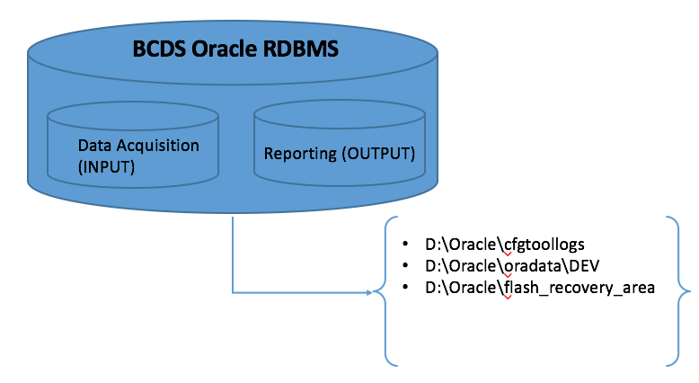

## Data View

BCDSS Application has three core logical data repositories in support for the data lifecycle within the system.

## BCDSS Data Ingest and Processing (INPUT)

Data Ingest & Processing (INPUT) Repository: This layer of the Logical Data Model (LDM) describes all the business entities that will be used to ingest predictive models and matrix data for the model before processing any claim(s) against the predictive model. Figure 16 shows the LDM for managing the data ingest and processing within BCDSS.

Figure : BCDSS Data Ingest & Model Repository

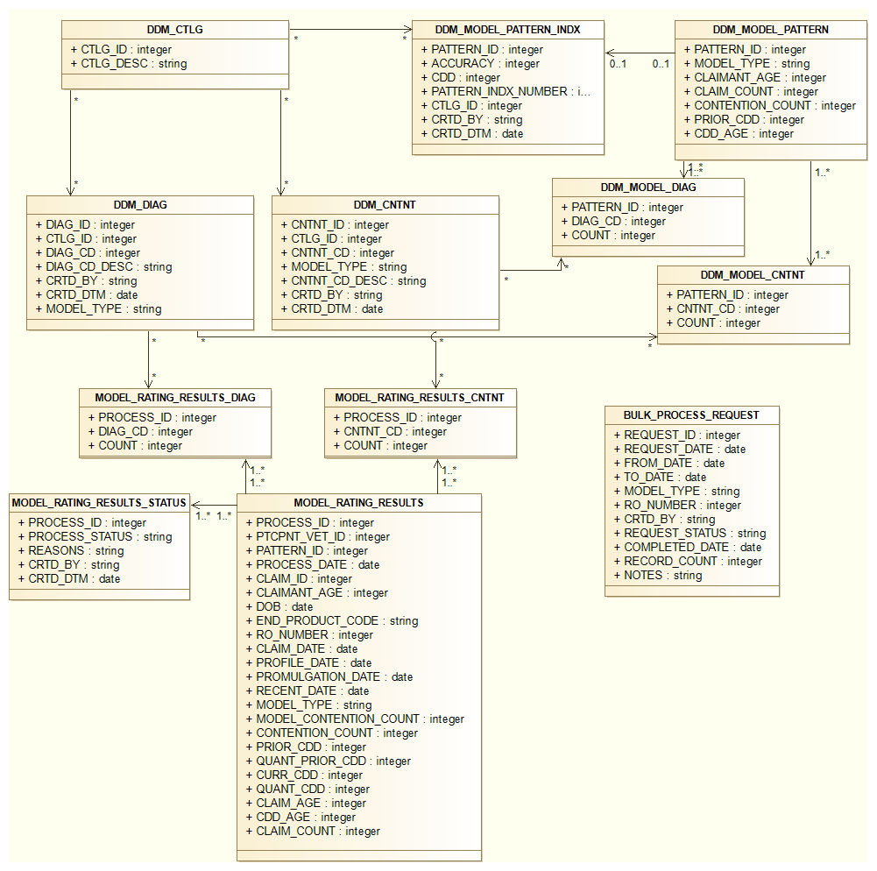

### BCDSS Role Based Access Control (Model Repository)

Figure 17 shows the LDM for how the BCDSS application will manage and maintain security within the system. BCDSS will use the role-based access control pattern, which will allow the system to track every user’s permissions, role, and actions.

Figure : BCDSS Role-Based Access Control

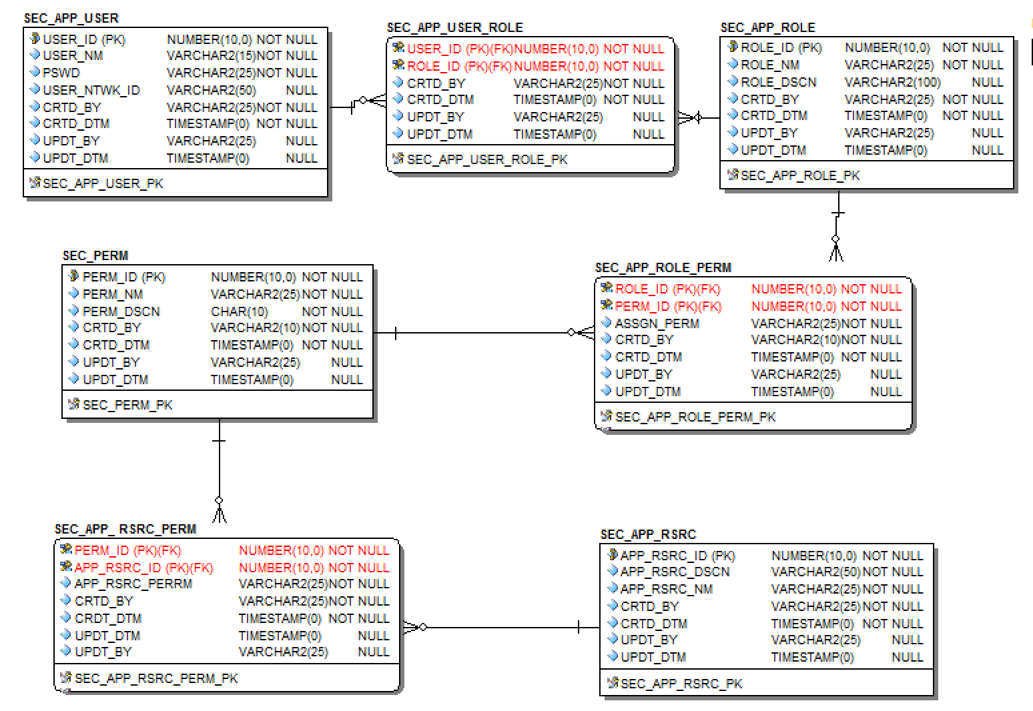

### BCDSS Predictive Model Metadata

Figure 18 shows the layer of the LDM used to track the properties and descriptive attributes of each predictive model. It does not include the run-time data supporting the model but rather the attributes used in the calculation of model results at run time.

Figure : BCDSS Predictive Model Metadata



# Detailed Design

The following section details each aspect of the BCDSS solution. This will be expanded to include each component of the solution as each are defined via the requirements process.

## Software Detailed Design

The Software Detailed Design is used to define the detailed design for all components of the BCDSS application, which are specified in the requirements.

The web application provides access to all BCDSS business services through web-based user interfaces. The BCDSS web application is based on HTML 5, AngularJS, CSS and ReST services and is deployed on Tomcat container. AngularJS is a structural framework for dynamic web applications. It handles all of the DOM and AJAX code and puts it in a well-defined structure. The application incorporates usability features for individuals with disabilities and provide the BCDSS system with section 508 compliance.

The server side components of BCDSS application consists of client request processing, business logic, technical services, and data transformation services.

Figure 19 shows high-level application component design of the BCDSS application.

Figure : Application Design



### Application Dashboard

The application dashboard displays the status of processed claims, Models, and various reports for the BCDSS application. The dashboard is designed as a Single Page Application (SPA), which loads as one HTML page which redraws its user interface without round trips to server. The client is a browser that runs JavaScript code to request the data and render updates to the page. The server is an API oriented architecture exposed through HTTP for items such as authorization, data access, business logic via CRUD (create, read, update, and delete). Node.js provides the base architecture for the web server providing the primary services of the dashboard through HTML, JavaScript, and CSS to drive the behavior of the application. Figure 20 illustrates various components required to populate application dashboard to the application user.

* Node.js (JavaScript runtime engine)
* Express.js (Node.js module used to handle routing of HTTP calls)
* HTML, JavaScript, and CSS
* Angular.js (JavaScript framework for extending HTML)
* Bootstrap (powerful front-end framework for faster and easier web development)

Figure : Application Dashboard



### Server-Side Components

The application uses Node JS as server-side technology for handling HTTP request response processing using ReST-based web-service calls. Custom components of the application use Java and Spring technologies. The modeling web-service component uses SOAP (Simple Object Access Protocol) specification for exchanging structured information between provider and consumer.

### Manage Models

The BCDSS application allows users to make controlled edits to existing models within the system. The user identifies what models should be ingested into the system. The application provides Add, Update, and Delete options for the models to authorized users. It uses the Angular JS framework to view the results and Hibernate/JPA for object relational database mapping. Figure 21 illustrates the data flow to populate model information to the user from the BCDSS database.

Figure : Manage Models



### Display Target Claims

The BCDSS application communicates with mock services for target claims data using Oracle database tables based on the user-defined filter criteria. The mock service response will be formatted to the BCDSS application format using data transformation service. Transformed data will be stored in BCDSS database and displayed on the application client’ page for user actions. Figure 22 illustrates the data flow to populate target claims data to the user.

Figure : Display Target Claims



### Apply Models to Target Claims

The BCDSS application displays available models that the application user will then select to process and analyze the selected claims. Figure 23 illustrates various components required for the apply models to the target claims data. The model conforms to BCDSS requirements by defining the specifications for the three core components of BCDSS models:

1) Decision Determination Matrix (DDM)

2) Target Claim Feature-Set Data and Computational Specifications

3) Claimant Feature-Set Data and Computational Specifications

Figure : Apply Models to Target Claims



### Reporting

The BCDSS reporting service offers useful features including matrices, ad-hoc reports, custom report items, and a variety of presentation formats such as PDF and CSV.

Types of reports include:

* Required standard reports
* Reporting histories for trending and monitoring of operational performance

## Specific Requirements

For further details on the specific functional requirements of the system, please refer to the BCDSS Requirements Specification Document.

# Security and Privacy

## Security

This section provides the security design principles, patterns, and specific implementation details for BCDSS. This document may be updated to reflect changes to the design as required supporting the expanding enterprise requirements for information security.

The BCSS Security Design shall be discussed in terms of:

* Physical Security
* Network Security
* Transport Security
* Message Security
* Application Security

### Physical Security

Addressing physical security is currently outside of the bounds of this document.

### Network Security

Addressing network security is currently outside of the bounds of this document.

### Transport Security

Transport security protects traffic between systems at the lowest software layer. When two systems communicate, first network connectivity must be established and then the transport technology takes over.

Transport Layer Security (TLS) and Secure Socket Layer (SSL) are transport cryptographic protocols that protect IP communications. Both TLS and SSL rely on the Public Key Infrastructure (PKI) certificate that enables both the encryption of communication and authentication & non-repudiation of certified holders. The VA uses 128-bit certificates issued by VeriSign, Inc. Certificate Authority (CA) under the VA Intermediate CA.

Figure : Browser Transport Security

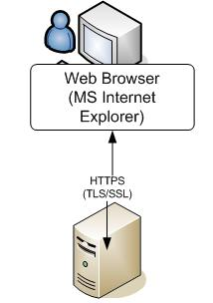

Figure 24 shows the application users connected to the VBMS Web Application with a web browser. The web browser uses Hypertext Transfer Protocol (HTTP) with TLS/SSL. The certificate of the server is provided to the browser which enables the user to verify the identity of the server as well as provide encrypted communication between the browser and the server. Encrypted traffic cannot be viewed by intermediate systems in the network chain.

While users interact with VBMS and other systems through a browser, many systems communicate directly with other systems and do not require a browser. Mutual Authentication TLS/SSL, often called two-way SSL, is required for system-to-system communications as shown in Figure 25.

Figure : Mutual versus Traditional TLS/SSL

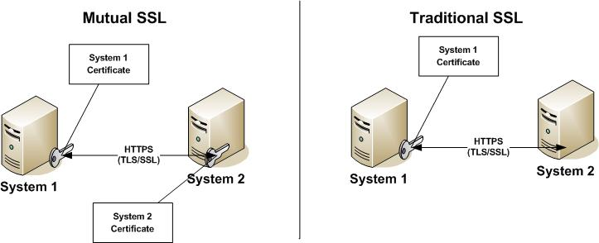

The primary difference between mutual and traditional TSL/SSL is that both systems require a trusted certificate presented during the protocol handshake. Both systems are able to enforce strict trust because both systems have authenticated. Mutual TLS/SSL provides an additional mechanism to protect unwanted network traffic from accessing the system.

### Message Security

For the pilot phase BCDSS, will not institute message-level security. However, when entering the VBMS enclave, per the VA 6500 Information Security Handbook, the confidentiality and integrity of messages between systems becomes a requirement. To address these requirements, the securing of a message is split into two concerns. The first, confidentiality, is achieved through encryption of the message itself. This is different from the notion of encryption of the tunnel, or transport, which is a point-to-point method versus an end-to-end solution. The second concern is integrity of the message, addressed by using digital signatures.

### Application Security

#### Authentication

Authentication is the process of determining if a user or identity is who they claim to be. Typical information systems rely on internal authentication mechanisms that perform the authentication against an internal or locally defined user directory. Most common authentication mechanisms include the use of some form of credentials, like a username and password, a digital certificate (such as Public Key Infrastructure (PKI)), or a biometric identifier to prove the identity of a user or system. Using one of these authentication mechanisms, a user is able to prove they are in fact who they claim to be. BCDSS currently employs a username and password as the credential set.

BCDSS is based upon HTTP Session Authentication within Spring Security. This state-full mechanism uses a token system stored within the server’s session context that is provided by the client’s cookie store. Longer state-full authentication, known as remember-me within Spring Security parlance, is achieved through the storage of the token outside of session and inside of the static persistence container, currently Oracle.

When BCDSS enters into the VBMS enclave the authentication mechanism will implement the same standardized approach required of all the systems. In summary, this is a centralized authentication service, shared user directory, and Security Assertion Markup Language (SAML) to facilitate security messaging.

#### Authorization Design

BCDSS currently uses Spring Security to implement a role-based access control model. As detailed in the authentication section of this security model, user attributes are provided to a system as part of the authentication exchange. One of these attributes is a user role. A Spring Security User is created, and assigned this role. Enforcement of the authorization policy occurs within the UI through direct role checks and in the controller layer via Spring Security Annotations.

## Privacy

Protecting the privacy of the veterans is a paramount concern for BCDSS given the sensitive nature of the medical information that BCDSS receives and processes. BCDSS employs a number of design concepts to protect privacy. Sensitive information is scrubbed from URLs by using HTTP POST to send this data as opposed to sending data via URL parameters. To ensure adherence to standards during development Open Web Application Security Project (OWASP) tools measure security weaknesses. Once BCDSS exits the pilot phase, PII/ Protected Health information (PHI) data becomes an issue and additional measures will be implemented to further ensure privacy. An example of this is full encryption of messaging between the server and end user. Specific to the VBMS enclave is the adherence to same station rules within the Benefits Gateway Services (BGS) to control information access.

# Human-Machine Interface

## Interface Design Rules

The user interface shall comply with VA standards, guidelines, Privacy Rules, and section 508 requirements.

## Inputs

BCDSS is a web-based system. All input occurs through the application’s standard HTML 5 interface. Messaging between the user browser and the BCDSS server(s) will occur using standard TCP/IP. Security of messaging will followthe VA standards. The use of user roles control access to areas of the BCDSS system, including all user interfaces.

### User Roles

Table 8 describes application user roles and responsibilities.

Table : User Roles

|  |  |
| --- | --- |
| **User Class** | **Description** |
| Model Agent | Identifies what models should be “ingested” into the system  Executes routine that verifies that a new model conforms to system specifications  Makes controlled edits to existing models within the system |
| Rater | Selects from those available within the system the target set of claims data to which models will be applied  Selects from those available within the system where and in what format modeling results will be output  Applies the models under the control of the system |
| Administrator | Authorizes from profiles available within the system user access and privileges  Defines where and in what format new models are readied for conformance testing and ingested  Defines what target claims data are available for modeling  Defines what formats and destinations are available for modeling results |

## Outputs

Outputs include data displayed on a web-based Dashboard, data sets resulting from application of models against claim data, as well as, generated reports.

## Navigation Hierarchy

The BCDSS User Guide will provide detail regarding interfaces, navigation, and expected behavior. Additionally, this section will be updated as the UI/UX is designed and approved based on defined application requirements.

### Logon

Figure 26 shows the user login screen.

Figure : Login Screen



Table 9 describes login screen fields.

Table : Login Screen Fields

|  |  |
| --- | --- |
| **Field** | **Description** |
| Login | User name to be authenticated. |
| Password | Password to be hashed and compared. |

### Rater Dashboard

Figure 27 shows the rater dashboard screen.

Figure : Rater Dashboard Screen

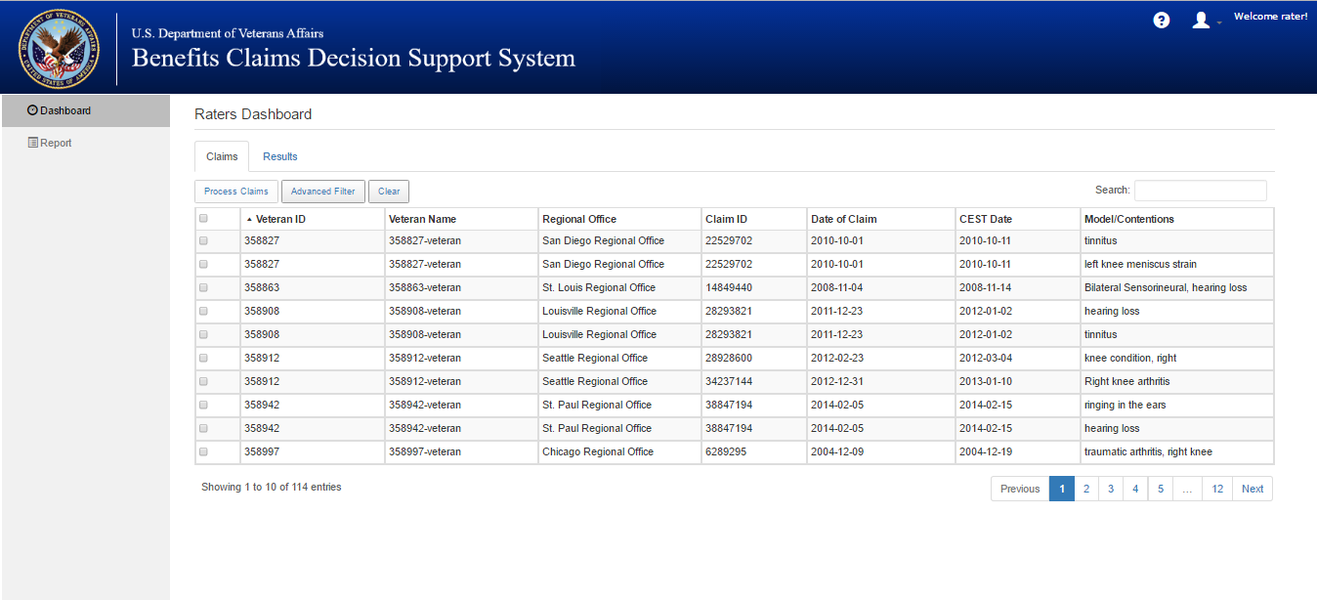

Target claims will be displayed in Rater’s Dashboard for further processing.

Figure : Rater Dashboard Search Screen

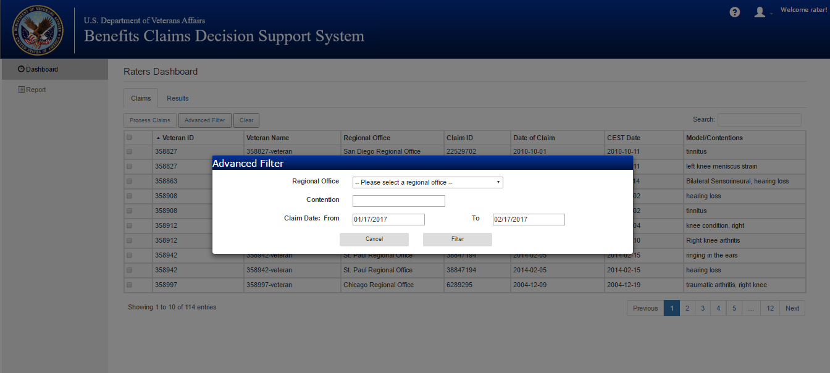

Table 10 shows filter fields for the raters dashboard search screen.

Table : Rater Dashboard Screen Fields

|  |  |
| --- | --- |
| **Field** | **Description** |
| Claim Date from | From claim date range |
| to | To Claim date range |
| Contention(s) | List of contentions available in Veteran’s file. |
| Regional office | Search by Regional office |

### Rating Results

Figure 29 shows the rating results screen.

Figure : Rating Results Screen

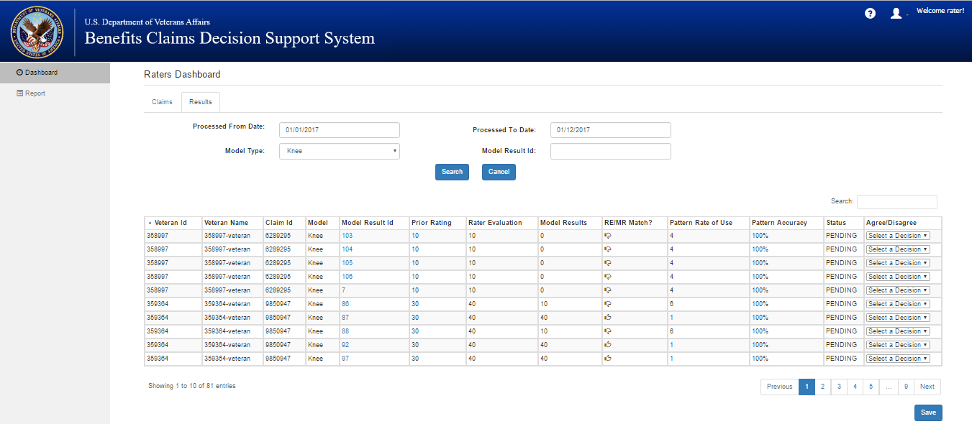

Rating results will be displayed in results page for further processing.

Table 11 shows filter fields for the raters dashboard search screen.

Table : Rating Results Screen Fields

|  |  |
| --- | --- |
| **Field** | **Description** |
| Processed from Date | Processed from Date |
| Processed to Date | Processed to Date |
| Model Type | List of model types supported by BCDSS application. |
| Model Result ID | By Result Id for rating results |
| Agree/Disagree | User will be able to take action on the rating results. |

### Reports

Figure 30 shows the reports filter criteria screen.

Figure : Reports Filter Criteria Screen

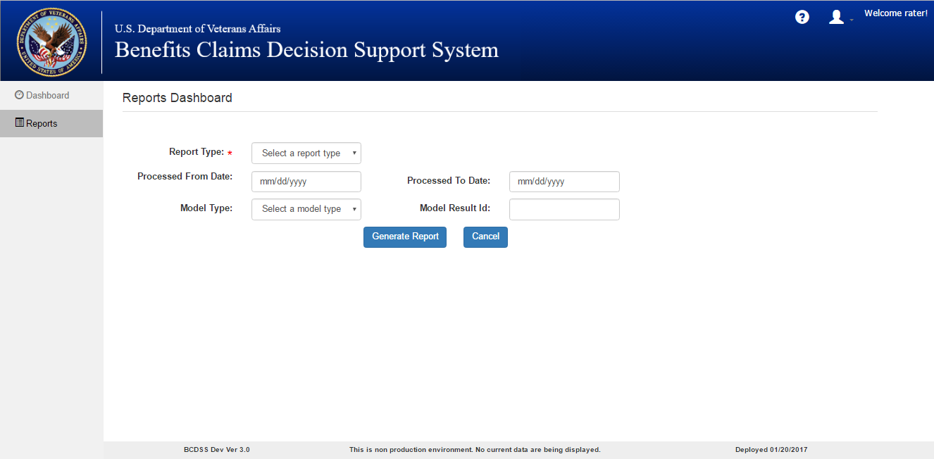

User input criteria will be entered through Reports screen.

Table 12 shows input fields for the reports screen.

Table 12: Reports Fields

|  |  |
| --- | --- |
| **Field** | **Description** |
| Report Type | User will be able select report type (ex: aggregate, detailed) |
| Processed from Date | Processed from Date |
| Processed to Date | Processed to Date |
| Model Type | List of model types supported by BCDSS application. |
| Model Result ID | By Result Id for rating results |

### Error Code and Descriptions

* ER 1001 – No records found for the veteran ID <ID> and claim ID <ID>
* ER 1002 – Did not find previous rating decisions for the selected veteran ID <ID> and claim ID <ID>
* ER 1003 – The service is currently unavailable. Please try after some time.

# Acronyms and Abbreviations

Table 13: Acronyms and Abbreviations

| Acronym | Term |
| --- | --- |
| AJAX | Asynchronous JavaScript and XML |
| APIs | Application Programming Interfaces |
| BCDSS | Benefit Claims Decision Support System |
| CDD | Combined Disability Determination |
| CDM | Conceptual Data Model |
| CRUD | Create , Read , Update , Delete |
| CSS | Cascading Style Sheet |
| DBMS | Database Management System |
| DOM | Document Object Module |
| ESS | Enterprise Shared Services |
| HTML | Hypertext Markup Language |
| JPA | Java Persistence API |
| KPIs | Key Performance Indicators |
| LDM | Logical Data Model |
| OWASP | Open Web Application Security Project |
| PMAS | Project Management Accountability System |
| RBAC | Role Base Access Control |
| RDBMS | Relational Database Management System |
| ReST | Representational State Transfer |
| SDD | Software Design Document |
| SOA | Service Oriented Architecture |
| SPA | Single Page Application |
| SQL | Structured Query Language |
| TRM | Technical Reference Model |
| UI/UX | User Interface/User Experience |
| VA | Veterans Affairs |
| VACI | VA Center for Innovation |
| VBA | Veterans Benefits Administration |
| VBMS | Veterans Benefits Management System |
| WSDL | Web Services Description Language |
| WS-I | Web Services Interoperability |

1. Additional Information
   1. Identification of Technology and Standards

Table 14: Standards

|  |  |
| --- | --- |
| **Standard** | **Reference** |
| National Institute of Standards and Technology (NIST) Special Publication (SP) 800-53 Revision 2 for the Federal Information Security Management Act (FISMA) compliance | <http://www.nist.gov> |
| NIST SP 800-27 | <http://www.nist.gov> |
| NIST SP 800-53 Revision 3 | <http://www.nist.gov> |
| Section 508 | <http://www.section508.gov/> |
| Section 508 Checklist for Software Applications and Operating Systems | <http://www.section508.va.gov/docs/checklist_1194_21.pdf> |
| Section 508 Checklist for Web-based Internet Information | <http://www.section508.va.gov/docs/checklist_1194_22.pdf> |
| VA Policy and Handbook 6500 | <http://www1.va.gov/vapubs/viewPublication.asp?Pub_ID=56> |

Table 15: Technology

|  |  |
| --- | --- |
| **Technology** | **Version** |
| Spring Framework | 4.1.6 |
| jQuery | 2.1.4 |
| AngularJS | 1.4.5 |
| Hibernate | 4.3.9 |
| Representation State Transfer (REST) |  |
| Spring Boot | 1.2.4 |
| Spring Security | 4.0.1 |
| Security Assertion Markup Language (SAML) | n/a |
| Web Services Security for Java (WSS4J) | n/a |
| Logback | 1.1.3 |
| Oracle | 11g |
| Tomcat | 7.0.68 |
| Jenkins | 1.6.50 |

* 1. Constraining Policies, Directives and Procedures

This document is based on the SDD template from ProPath. Creating the SDD is part of the process of determining requirements during project planning. ProPath guidance expects the SDD to come before (or at the same time as) the Project Management Plan (PMP). The policy is to follow the PMAS version 5.0+ and the ProPath version 9.0+ processes and documentation.

* [U.S. Department of Veterans Affairs (VA) Project Management Accountability System (PMAS) ProPath Guidelines](http://vaww.oed.wss.va.gov/process/home.aspx);
* VA’s interpretation of Section 508 of the Rehabilitation Act of 1973 as governed by the VA Section 508 Office and documented on the [Section 508 Office Web Page](http://vaww.vista.med.va.gov/508workgroup);
* [Privacy Impact Assessment—Privacy Service](http://www.privacy.va.gov/Privacy_Impact_Assessment.asp);
* Federal Information Security Management Act (FISMA);
* VA Directive 6500 Directive and Handbook, Information Security Program;
* VA Handbook 6221, Accessible Electronic Information Technology (EIT);
* National Institute of Science and Technology (NIST) 800-53;
* Federal Information Processing Standards (FIPS); and
* Continuous Readiness in Information Security Program (CRISP).
  1. Requirements Traceability Matrix

The BCDSS RTM CLIN0002AB that traces modules and data structures to the software requirements has been provided below and in delivery to the VA along with this document at the same time. It is a Living Artifact and will be added to/ updated at each stage though the lifecycle.

The latest RTM document can be found at: <https://github.com/VHAINNOVATIONS/BCDS/tree/master/Documentation/Monthly%20Deliverables/RTM>

* 1. Packaging and Installation

Build scripts orchestrate the compilation of source code, execute unit testing, create code coverage reports, and automatically deploy into development integration environment. An automated build framework not only helps solve integration issues early, but also helps build and deploy the complex products quickly, all while ensuring that the build processes are transparent, auditable and repeatable.

# Approval Signatures

This section is used to document the approval of the Software Design Document. The review should be conducted face to face where signatures can be obtained ‘live’ during the review. If unable to conduct a face-to-face meeting then it should be held via LiveMeeting and concurrence captured during the meeting. The Scribe should add /es/name by each position cited. Example provided below.

The Business Sponsor and Project Manager are required to sign.

______________________________________________________________________________

Signed: Date:

< Business Sponsor >

______________________________________________________________________________

Signed: Date:

< Project Manager >